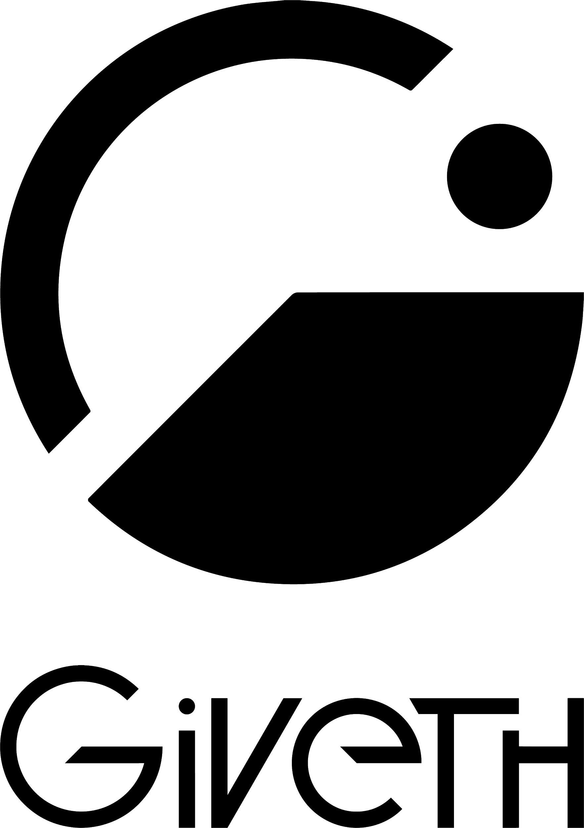

Giveth Brand and Visual Identity

Devcon3, Cancun 1-4 Nov, 2017

**About Giveth**

Giveth is committed to develop an open source Dapp that inspires ‘Decentralized Altruistic Communities’ (DAC) to connect through common purpose, co-create and transform the world in support of good cause.

**Our Brand is represented in two environments: The Dapp and Unicorn DAC**

Giveth is the Dapp (platform) developed by the Unicorn DAC, both can be viewed as community led projects, not organizations, not charities, not legal entities. The Unicorn DAC’s mission is to develop the Giveth platform, it is defined by the team’s drives and shared values supporting transparency, open-source development and collaborating with like-minded projects. The Unicorn DAC encourages similar initiatives to co-create and to organize themselves as DACs and not competitors, sharing similar goals and objectives, we all strive to make the world a better place.

**Devcon3 Sponsorship**

Giveth will soft-launch its mvp at Devcon3, there will be a continuous use of the #FutureOfGiving hashtag that will play an important role in the Giveth public relations campaign. Aiming at commemorating this special event and engaging the Ethereum community on the adoption and support of the Giveth donation platform, the following are mock-ups of the intended promotional material:

1. T-Shirts: 200

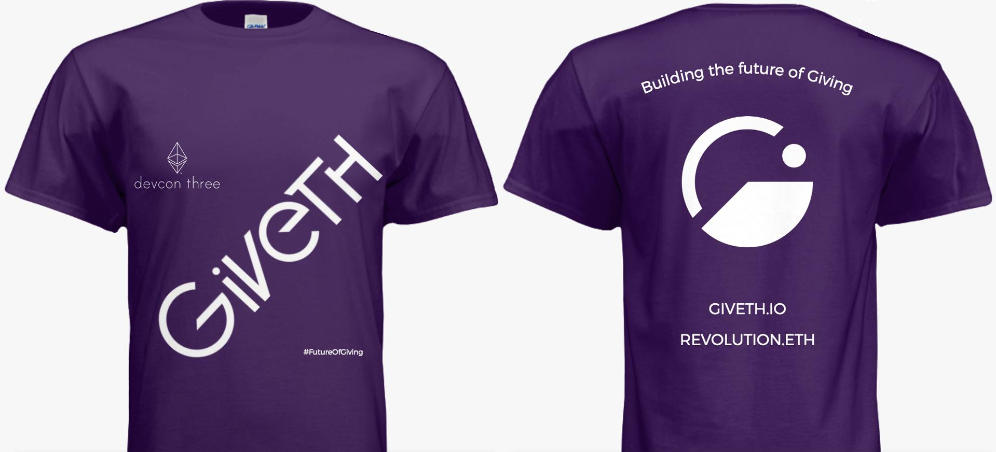

2) Frisbees: 100

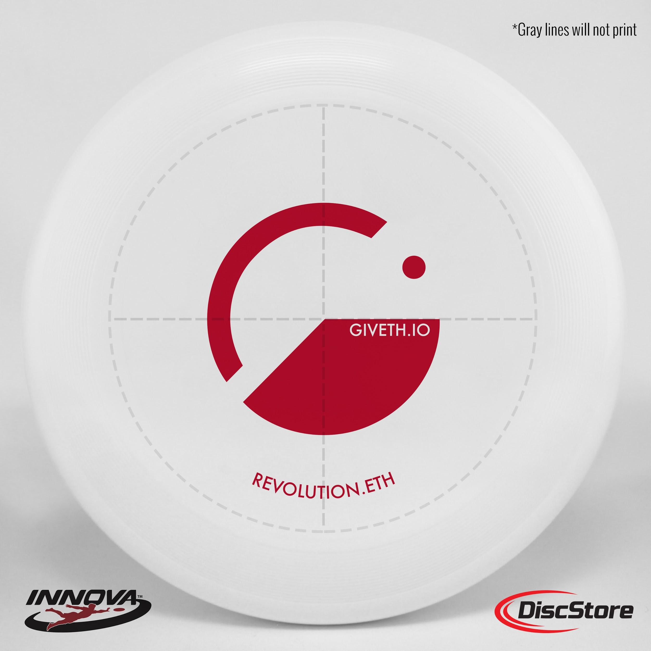

3) Giveth multi-purpose sack: 30

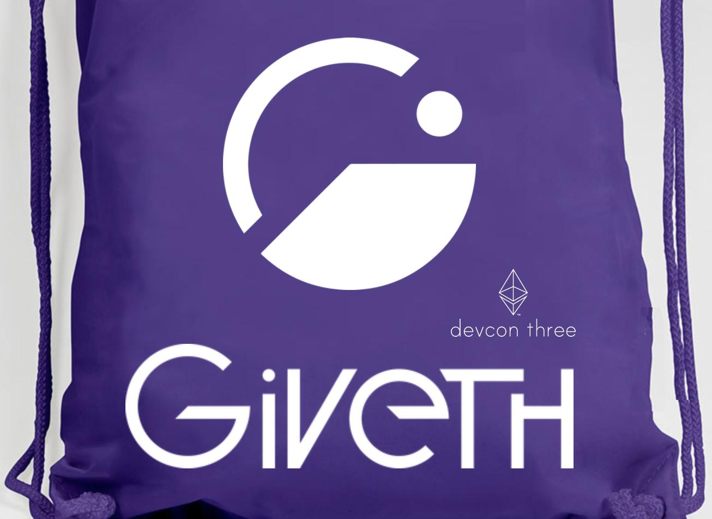

4) Giveth Flags - use for Display only